

Information Systems Engineering Department   
Braude College of Engineering

Capstone Project Phase B – 61999

**Preliminary diagnosis of Alzheimer’s**

**using Virtual Reality**

[Link to project materials](https://drive.google.com/drive/folders/14N2MBjFmDDK973lyYq_AcAIKfnu3Ud0J)

**Project No: 24-1-D-17**

**Advisors:**

Dr.Anat Dahan

Associate Professor-Marcela Viviana Karpuj

**Writers:**

Tali Azoulay - [Tali.Muchnik@e.braude.ac.il](mailto:Tali.Muchnik@e.braude.ac.il)

Id:205471204

Aviv Ben Ezra – [Aviv.Ben.Ezra@e.braude.ac.il](mailto:Aviv.Ben.Ezra@e.braude.ac.il)

Id: 313596355

**Table of Contents**

**Abstract** 2

**Introduction** 3

**Development Process** 5

**Diagrams** 7

Unity XR Diagram [4] 7

Structured layout of the VR development process 8

**Visual Scenes And Flow** 9

Welcome Screen 9

Simulator Screen 10

General Instruction Screen 11

Hebrew Screen 12

Video Screen 13

Not Finding Screen 14

Finish Screen 15

Supermarket Shots 16

16

**Challenges And Solutions** 17

Hardware Challenge 17

Graphics Challenge 17

Software and Debugging 17

Low FPS 17

Sending Emails and Showing Videos 18

**Decisions** 19

**Tools** 20

**Testing** 21

**User Manua**l 22

**Operation And Maintenance Guide** 23

**Results** 24

**Conclusions** 26

**Future Features** 27

**References** 28

# Abstract

**Virtual reality (VR)** has emerged as a powerful tool in the medical field, offering innovative solutions for both treatment and diagnosis. One field where VR shows significant promise is in the early diagnosis of Alzheimer’s disease, a neurodegenerative condition that impairs cognitive functions such as memory and spatial navigation.

**The Virtual Supermarket Test (VST)** is dedicated to diagnosing Alzheimer’s disease in its very early stages. This is crucial, as early diagnosis can significantly improve the quality of life for patients. The VST is designed as a diagnostic game, providing a virtual environment that mimics daily tasks, such as navigating a supermarket, allowing for efficient cognitive assessments. The VST complements traditional tests.

Here we show that the VST tracks key cognitive metrics. The subject is required to watch a short video and then follow a specified route. This process is repeated five times. During navigation, the system collects data such as whether the subject found the product and the time taken. It is beneficial to include additional factors like bumps and hesitations to enhance the assessment.

The test results highlight the diverse abilities of older adults in navigating VR environments. While some participants successfully located all five products, others (the older ones) struggled, indicating a need to simplify navigation and extend search times. Additionally, testing with a larger sample size is essential to better understand and address the challenges faced by this demographic.

Our results show that the VST adds significant value compared to traditional diagnostic and compared to other versions by providing real-time objective data in a realistic and interactive environment.

In a broader context, the VST represents an advancement in neurodiagnostic tools, combining technology and healthcare expertise. It incorporates user feedback to improve usability and assists the diagnosing medical team, ultimately creating a scalable solution for Alzheimer's diagnosis.

# Introduction

In recent years, virtual reality (VR) has emerged as a revolutionary tool in the medical field, offering innovative solutions for treating and diagnosing patients.

VR offers numerous advantages. Firstly, it eliminates space constraints, allowing navigation tasks to be conducted simply by wearing VR glasses. In contrast, traditional methods required medical personnel to arrange a specific route and assemble a team for examination. Additionally, traditional tests can induce stress and fear, whereas VR glasses provide a more enjoyable and can improve patient management.

The primary goal is to identify Alzheimer’s disease in individuals at very early stages, even before brain changes become visible. Early diagnosis can significantly improve living standards by enabling timely treatment. Although Alzheimer’s has no cure at the moment, timely diagnosis allows for the implementation of appropriate care strategies to slow disease progression.

One of the most effective ways to detect dementia, particularly Alzheimer’s disease, is by examining daily life functionalities. However, hospitals often lack the necessary resources, such as time and personnel, to perform these examinations. This VR diagnostic tool addresses these issues by providing an easy and effective way to assess patients’ daily life functionalities.

Additionally, there is a genetic predisposition to Alzheimer's disease, particularly with the presence of the APOE ε4 gene [1], which increases the risk of late-onset Alzheimer’s. People concerned about their genetic risk or cognitive health can use this VR tool for self-monitoring, comparing their own performance over time. Tracking their abilities in tasks like spatial navigation can help detect any early signs of decline and encourage timely medical consultation.

Research shows that patients with early-stage Alzheimer’s disease often struggle with spatial navigation [2], particularly in the early stages, but they can also appear in other types of dementia, though usually less prominently. In AD, spatial navigation problems are more consistent and pronounced.

That’s why its important to distinguish Alzheimer's from other forms of dementia in the early stages. Considering these factors, the chosen test environment is a virtual supermarket.

This project aims to assist the medical team in the early diagnosis of Alzheimer’s disease and serve as an additional examination to the existing ones. This VR-based system seeks to provide supplementary indicators to the medical team, helping to identify patients who might be classified as healthy by traditional tests.

The diagnostic tool is designed as an interactive game where subjects perform a simulator stage to familiarize themselves with the virtual environment. The game comprises five stages, each requiring the subject to watch a short navigation movie and mimic the route. Upon selecting the correct product, the subject is teleported to another spot in the virtual supermarket to start a new navigation process. A time limitation ensures that if the subject fails to find the correct product, they are automatically moved to the next area.

This VR-based system aspires to provide a realistic and engaging diagnostic experience by utilizing high-quality 3D graphics, high responding time by combining real sensory experiences through music and haptic effects.

The system records various metrics, including the number of correct products found, the time taken, any bumps encountered, and moments of hesitation. These results provide valuable insights into the subject’s cognitive and navigational abilities. These factors should assist the primary doctor in the complex diagnosis process.

During the development of the project, a consultation was held with Dr. Spector, a senior physician at Carmel Hospital who leads the identification of dementia diseases. She specified the requirements according to the needs of the hospital and the diagnostic team.

In summary, this VR-based diagnostic tool aims to facilitate the early diagnosis of Alzheimer’s disease by providing a convenient, engaging, and efficient solution for both patients and healthcare providers. Through the integration of advanced VR technology, this project seeks to improve the quality of life for individuals at risk of Alzheimer’s [3].

# Development Process

The development process began with acquiring the appropriate hardware and downloading the necessary VR applications. The development utilized the Oculus Quest 2 device, which is what is available in our college, and Unity game engine, and C# language. This involved working with four applications simultaneously: Unity Editor to create objects and manage packages, Unity Hub to store and manage engines, projects, and packages, a bridge application to connect the headset with the PC and grant control via the PC, and Visual Studio Editor for coding.

Understanding the different development applications and their simultaneous operation was crucial, as each application offered unique features and options. Grasping the basics of VR was also essential. There were challenges such as avoiding VR sickness which is include dizziness, nausea, headaches, sweating, and sometimes disorientation, creating realistic experiences, and choosing the optimal movement and reaction methods. These challenges sometimes conflicted, but finding a good balance was key to creating a better game and user experience. For example, to avoid VR sickness we choose consistent frame rate of at least 60 FPS to provide a smooth experience, and ensure users sitting in a stable position, with a clear area around them to avoid any physical accidents.

The diagnostic game includes 3D sounds such as supermarket checkouts, moving carts, and classical music that characterizes and associates with shopping. Additionally, the diagnostic game incorporates haptic effects. Whenever the user picks up a product, the joystick vibrates, which simulating the real-life sensation of touching objects. This combination of auditory and tactile feedback enhances the realism and immersion of the VR experience.

C# coding played a significant role in the development process. This included learning how to retrieve objects from the editor and scene, working with the hierarchy, real-time programming (commands that occur every frame), and application maintenance, which involved good object-oriented programming and appropriate documentation. All these efforts enabled the creation of much more precise functionality for the diagnostic game.

Optimization was another critical aspect, focusing on maximizing frames per second while minimizing drawbacks and polycounts. Post-processing techniques also contributed to achieving these goals, including occlusion, light baking, and setting objects as static. All these efforts aimed to enhance performance and provide the user with a smooth and realistic experience.

Familiarity with developer tools such as the profiler, stats, and Android Debug Bridge (ADB) was also an integral part of the development process. The profiler enabled the detection of crashes and provided insights into their causes. The stats helped identify system loads, while the ADB allowed developers to control the Oculus without wearing the device and even manage it during crashes. These tools were essential for monitoring performance, ensuring a stable application, and providing smooth movement for the user.

The development process was iterative, with main features being defined and developed in a back-and-forth manner. Basic features were initially created and then continuously improved based on ongoing learning and subsequent development. This approach ensured the creation of a robust and effective VR diagnostic tool.

# Diagrams

## Unity XR Diagram [4]

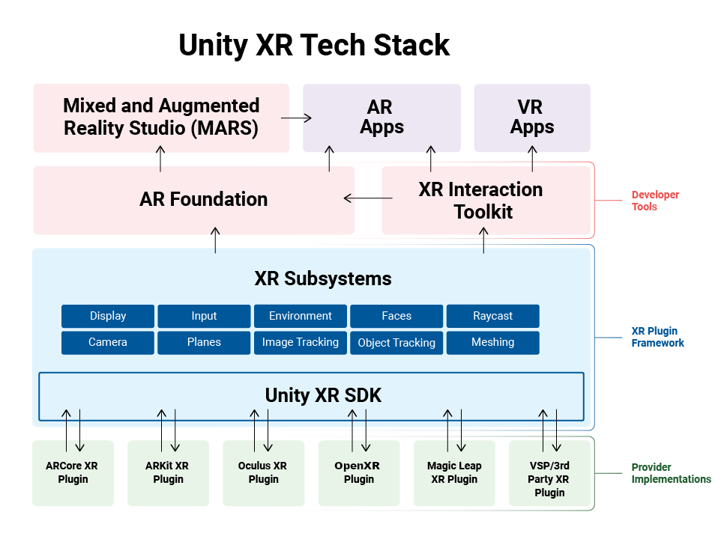

Figure 1: Unity XR Diagram

XR refers to the spectrum of experiences that enhance or replace reality through digital means(AR,VR,MR). The diagram emphasizes how the Unity application is independent of the specific hardware, relying on XR Management and plugins to handle the details of interacting with various XR devices.

**XR subsystems** are like common tools that XR features use. **XR plug-ins** use these tools to provide data to your app. You can access this data through Unity Engine and package APIs.

**XR provider plug-ins** are Unity plug-ins that support different XR devices. For example, the ARCore plug-in works with Android AR devices, and the OpenXR plug-in works with many XR devices on different systems. These plug-ins use the device’s native libraries to work with Unity.

Unity uses these subsystem tools to talk to different XR devices, making it easy to use the same code for different devices. You can switch the active provider and rebuild your app for different XR platforms if they are similar. Unity Engine has basic XR subsystems, and additional ones can come from Unity packages, like the AR Subsystems package for AR-specific tools[5].

## Structured layout of the VR development process

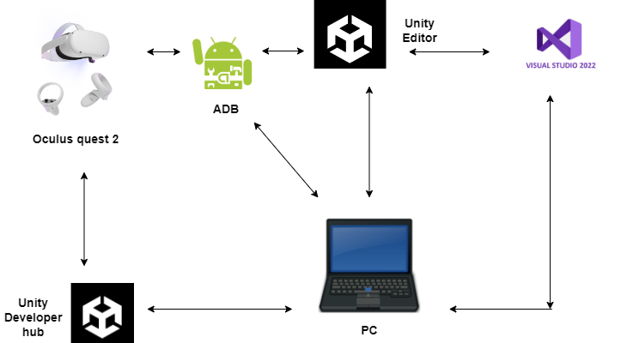

Figure 2: Development Process Diagram

The diagram shows a development setup where the **PC** is central, connecting to **Unity Editor** for development and **Visual Studio 2022** for coding. The **Unity Developer Hub** and **Oculus Quest 2** are linked, with the **ADB** (Android Debug Bridge) providing control and debugging support between the PC, Unity Editor, and the Oculus device. Each tool plays a unique role in facilitating VR development, testing, and debugging.

Using the joystick for navigation and interaction will enhance the user's engagement with the scene and products. All you need to do is pointing with the lasers of joystick on the product.

The PC is crucial for development, testing, and performance optimization. We can use the PC to mirror the VR experience on a monitor, which can be helpful for presentations or demonstrations to others who aren't wearing the headset. We can use Unity to build and refine our game, making it easier to debug and optimize performance.

Using a PC adds cost because VR-capable systems often require high-end hardware, especially a powerful graphics card, to render immersive environments smoothly, which can be pricey. Furthermore, a desktop or laptop setup is generally less portable than standalone headsets, making it harder to transport or set up in different locations.

# Visual Scenes And Flow

## Welcome Screen

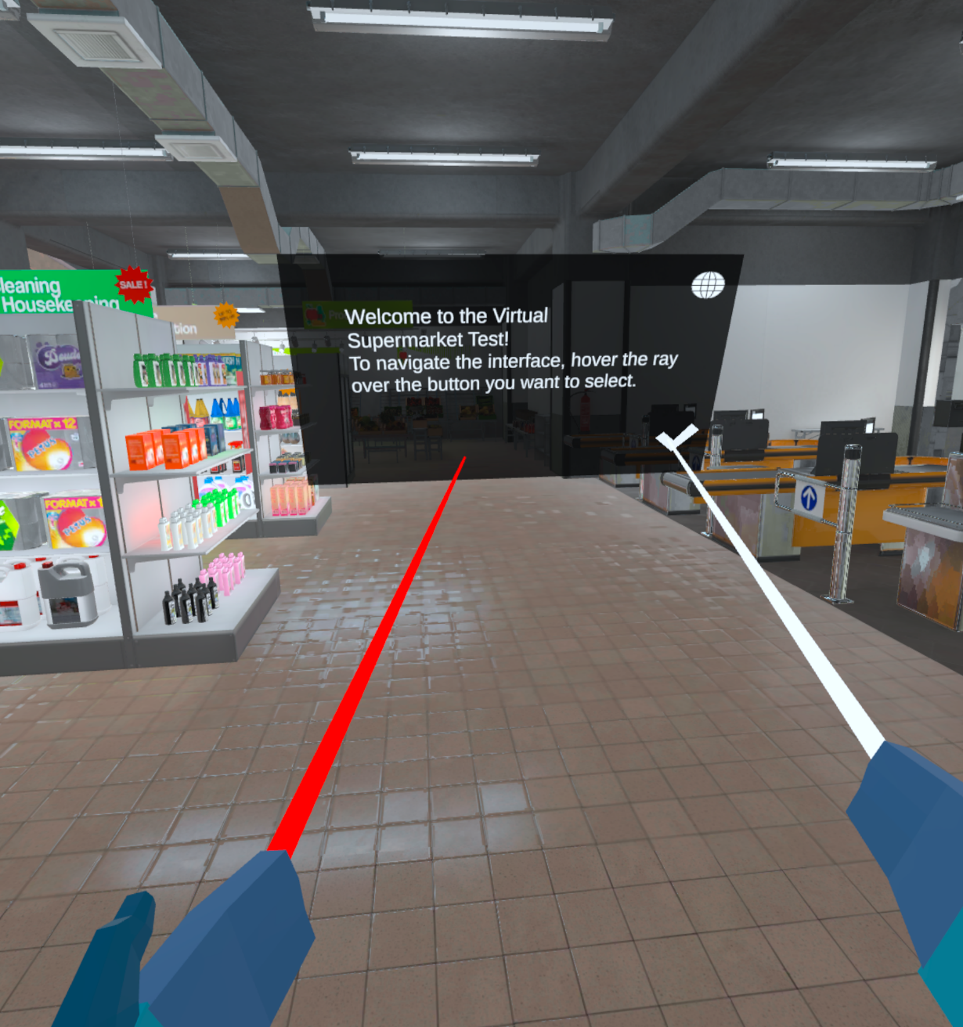

The player arrives at a virtual supermarket, hearing checkout sounds and a cart from the right, along with low classical music from the left, all designed to provide a realistic experience. They see a black canvas explaining the introduction of the test, which includes two icon buttons: ‘Ok’ and ‘Change Language’. At this stage, the player begins the simulator phase, learning the diagnostic game step by step. Additionally, the player gets accustomed to the new red rays emanating from their hands. This introductory part lasts for one minute.

## Simulator Screen

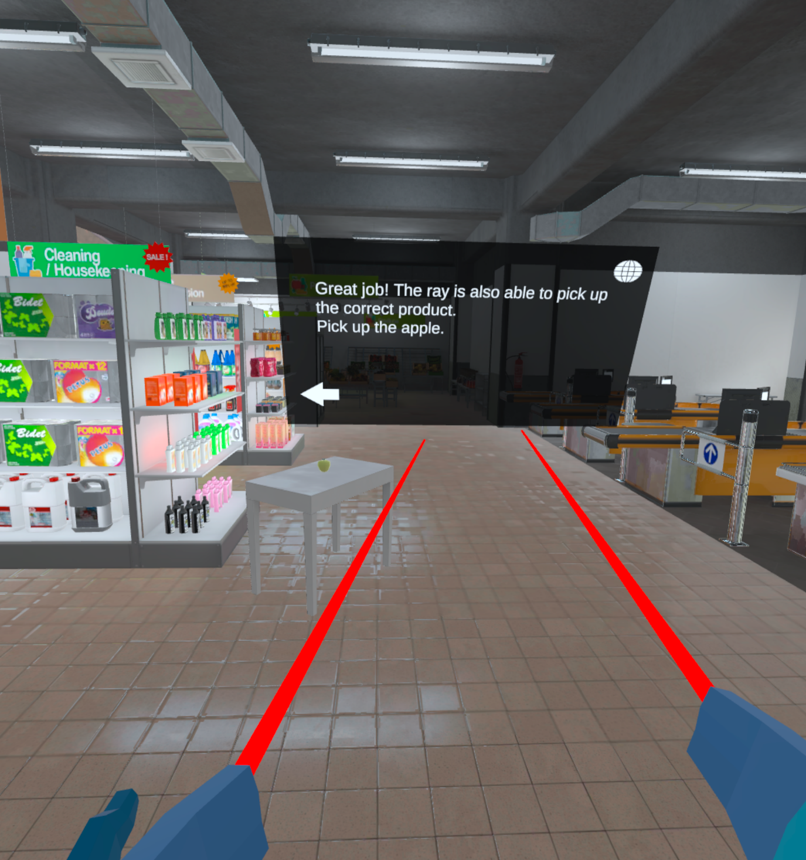

On the next screen, the player learns to pick up a product using a laser ray in an interactive manner. A table with a green apple appears in front of the player. To proceed to the next screen, the player must pick up the green apple. The player also has the option to go back to the previous screen. Mastering this skill is necessary for the subsequent game stages.

In the future, it will also be essential to measure the time it takes for participants to learn and interact with the system. This way, we can compare the performance of healthy individuals with that of those diagnosed with Alzheimer’s disease. For example, will individuals with Alzheimer’s require more time to learn and navigate the game? By tracking these metrics, we can gain valuable insights into the differences in learning and adaptation between healthy participants and those with Alzheimer’s.

## General Instruction Screen

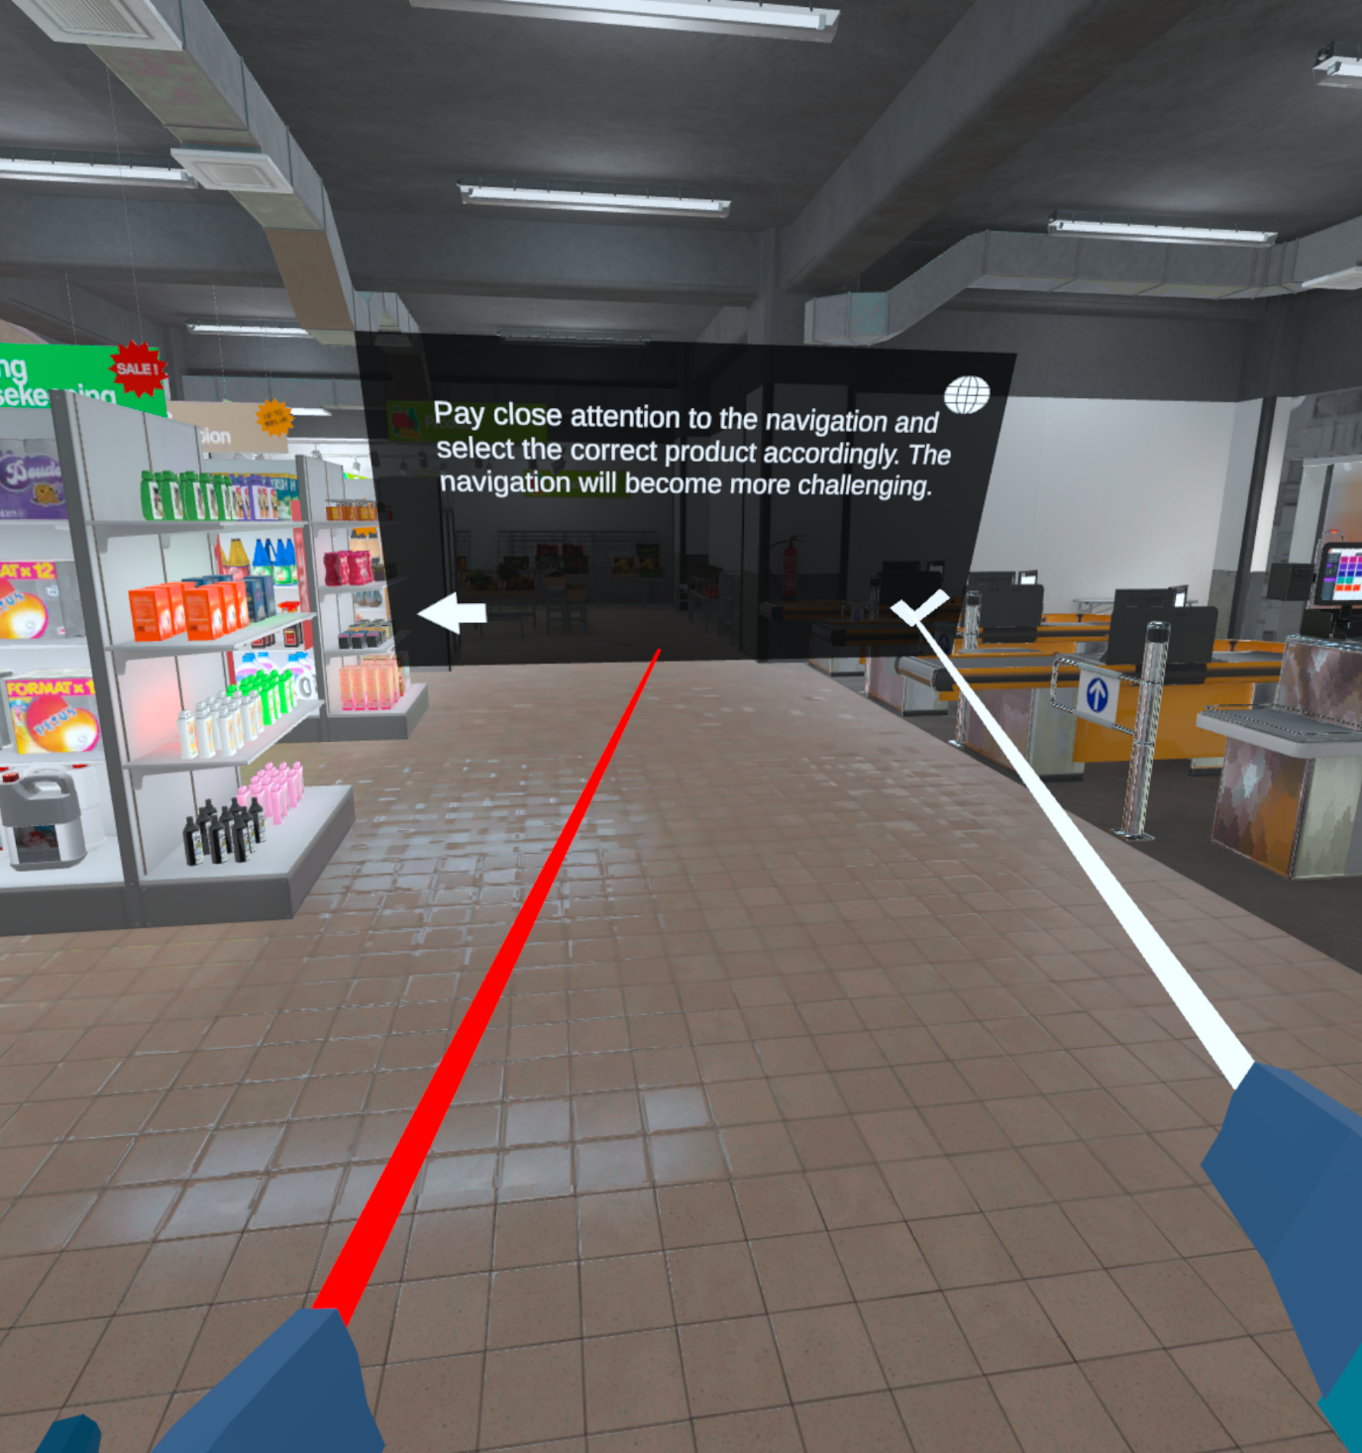

This serves as a general instruction for the rest of the diagnostic game. The player can switch between languages as needed. When the player points at a button, the ray turns white to indicate that it is clickable. The rules are simple: the player must watch a short movie and then repeat the route shown. This process needs to be repeated five times.

## Hebrew Screen

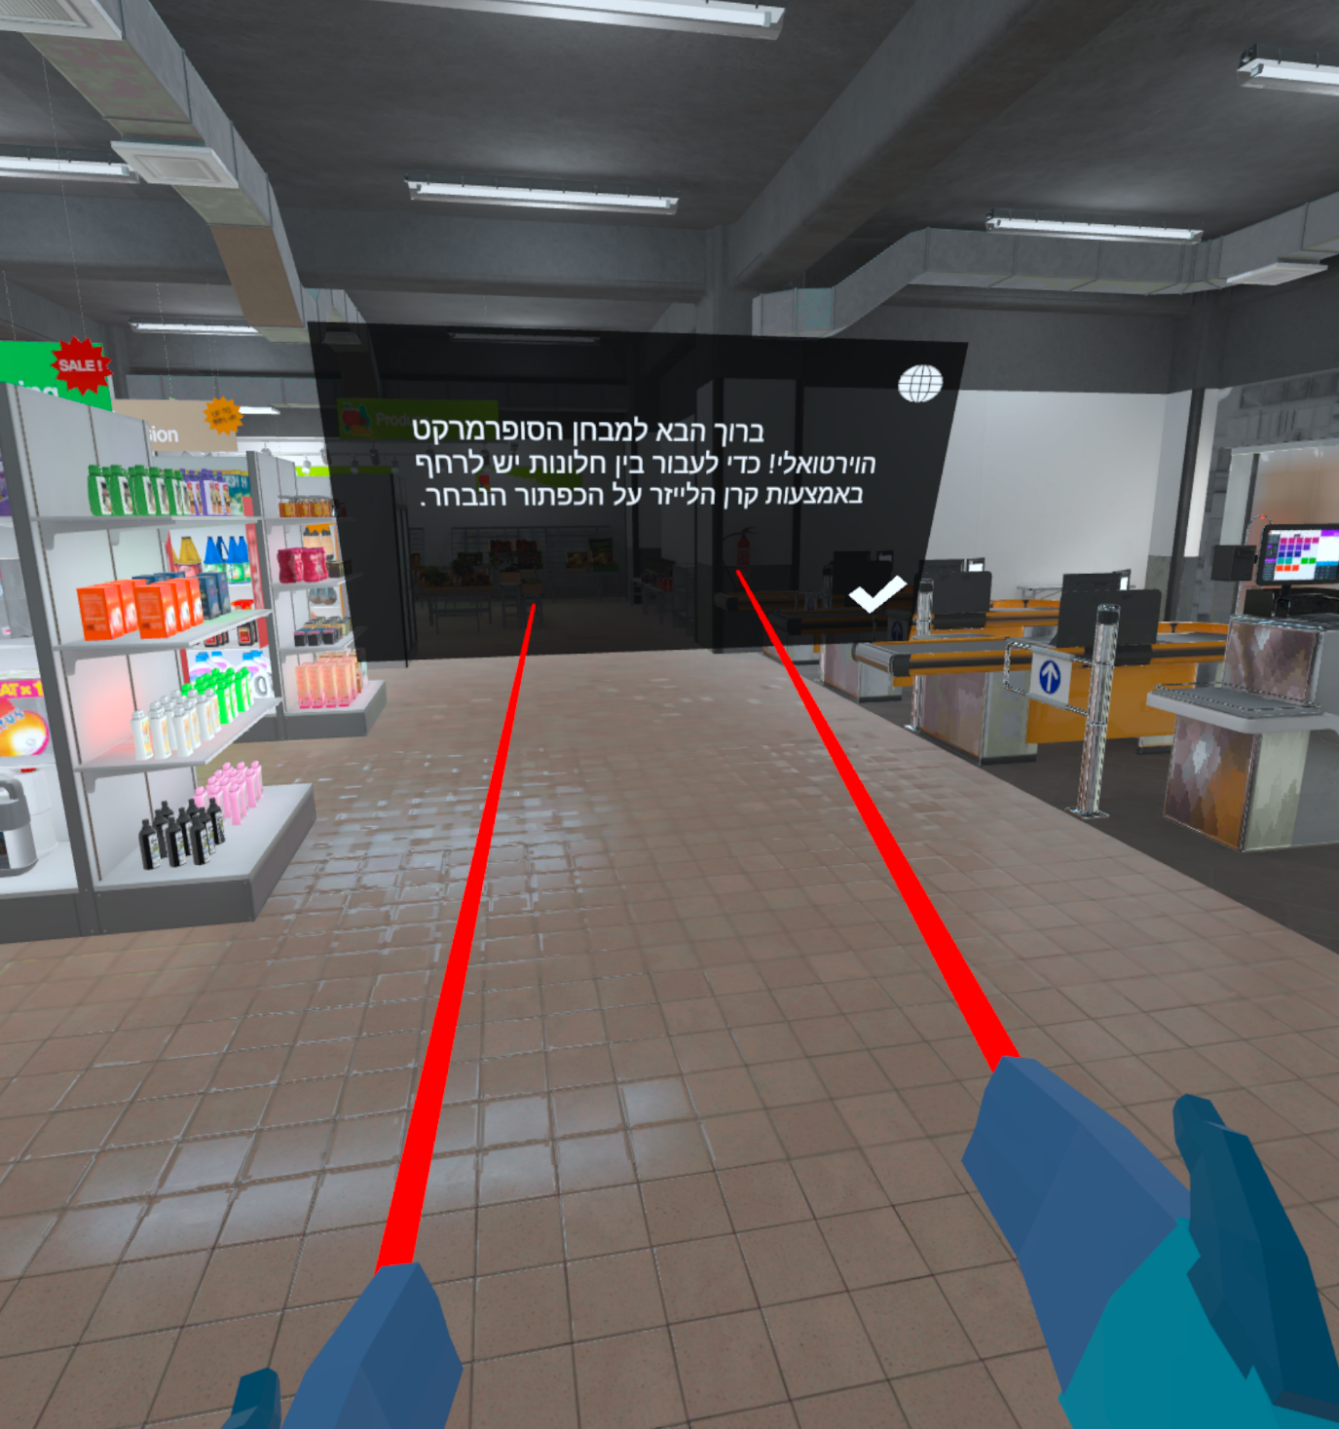

Creating instructions in Hebrew was also necessary, following Dr. Spector’s guidance, as the product is intended for older adults. The Hebrew instructions are designed to make it easier for the user to focus on navigation.

## Video Screen

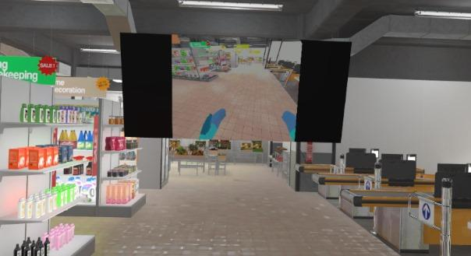

The short movies are recorded from a first-person perspective. In each movie, a product is marked, and the player must pick up that product or one from the same group to start the next navigation. After picking up the correct product, the player is teleported to the next navigation area. Alzheimer's patients are expected to struggle with mimicking the route. During navigation, various statistics, such as the time taken, are recorded.

## Not Finding Screen

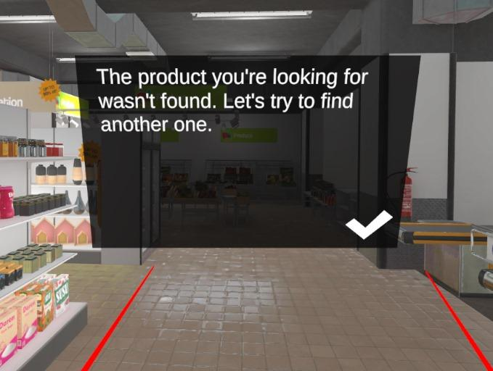

There is a time limit. If the player struggles to find a product, a ‘Not Found’ screen pops up and freezes their ability to move until they press OK. Behind the scenes, the product is marked as ‘Not Found,’ and the user is teleported to the next area to start the next navigation.

## Finish Screen

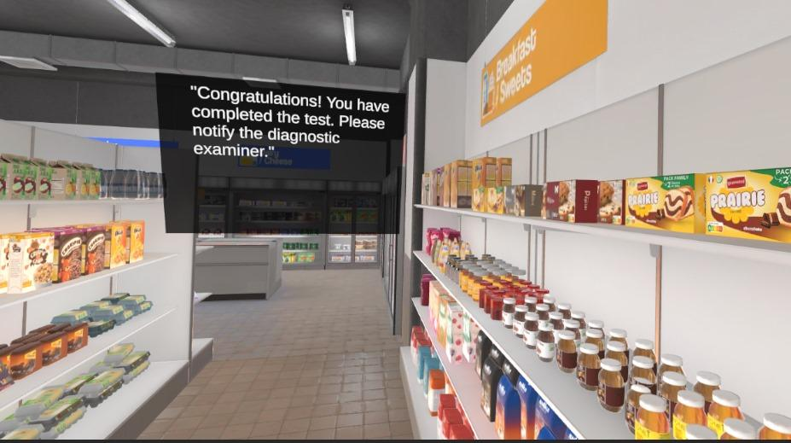

After the player picks up the last product, a finish message pops up. At this stage, a CSV file is created on the computer, allowing the medical team to assess the results. Additionally, the assessor can watch the subject throughout the entire gameplay.

## Supermarket Shots

## 

These photos represent the supermarket area visible inside the VR Oculus device. The scene includes numerous products, aisles, shelves, refrigerators, and more. The user hears 3D sounds: buzzing from the checkout area, carts from the aisles, and classical music from the walls. Additionally, there is a haptic effect from the joystick when picking up products. All of these elements contribute to a realistic experience.

# Challenges And Solutions

## Hardware Challenge

At the start, I realized my graphics card was not compatible with the bridge software needed to develop applications on the Oculus. This was a significant setback, as the bridge software is crucial for connecting the VR headset to the development environment. I found a computer lending program from NVIDIA, which provided me with a suitable computer according to the Meta Oculus hardware requirements [6]. We switched graphics cards three times, trying different models and configurations, until we figured out that a gaming card was required. This process involved a lot of trial and error, but it was a valuable learning experience in understanding the hardware requirements for VR development.

## Graphics Challenge

After downloading the supermarket asset, I encountered an unexpected issue: the entire scene appeared pink. This was frustrating because it indicated a problem with the shaders or materials. I tried numerous solutions, including re-importing assets, adjusting settings, and consulting online forums. Finally, I discovered that the supermarket asset had its own set of properties that needed to be adjusted. By accessing and modifying these properties directly, I was able to resolve the issue and restore the correct appearance of the scene.

## Software and Debugging

VR development involves working with a variety of applications and tools, each with its own learning curve. Initially, I had to familiarize myself with the basics of Unity, C#, and the Oculus SDK. As I progressed, I learned how to integrate these tools and manage their interactions. Debugging was particularly challenging at first, but over time, I became more proficient. I discovered many useful tools and techniques that made the process faster and more efficient. Despite this progress, we recognize that there is still much to learn, and we continue to explore new methods and technologies to improve the workflow[7].

## Low FPS

After installing the app on the Oculus, I noticed that the frame rate was very low, which significantly impacted the realism and immersion of the experience. To address this, I had to optimize the application. This involved several strategies, such as implementing occlusion culling to reduce the rendering load, changing dynamic objects to static where possible, and finding a balance between graphical fidelity and performance. These optimizations were crucial in enhancing the user experience and ensuring smooth, realistic interactions within the VR environment[8].

## Sending Emails and Showing Videos

 I found tasks like sending emails and showing videos within the VR environment particularly challenging. These features are important for providing instructions and feedback to users, but integrating them into the VR application was not straightforward. Initially, I struggled to find a solution. Eventually, I realized that using the Unity editor play mode could help simulate these functionalities. This workaround allowed me to test and refine these features, ensuring they worked seamlessly within the VR experience.

# Decisions

Developing the VR-based diagnostic tool for early Alzheimer’s disease detection has been a challenging yet rewarding journey. Throughout the process, we have made several critical decisions to ensure the product is both effective and user-friendly.

During development, the product was shown to Dr. Spector. She pointed out that the product was too complicated for older users and needed to be simplified. Together, we decided that picking up products using a laser pointer, rather than by hand, would significantly simplify the application. In this case, we had to sacrifice some realism for simplicity. This change was crucial as it made the tool more accessible to older adults, who are the primary users.

The order of features was determined by the teleportation functionality. Initially, efforts were focused on this task. For teleportation, the project needed to incorporate VR capabilities such as laser pointers and movement. Once this was established, we could build upon it. This foundational feature allowed users to navigate the virtual supermarket efficiently, setting the stage for more complex interactions.

Another important decision was the level of navigation. It was necessary to create numerous navigation tasks and choose the best ones based on player feedback. The navigation difficulty accelerates as the user progresses through the tasks. Although I tested the application only with healthy subjects, all of them should be able to succeed in the tasks, but they should not be too easy. This progressive difficulty ensures that the tool can effectively assess spatial navigation abilities, which are often impaired in early Alzheimer’s disease.

Creating the simulator was another crucial decision. We had to determine the best way to make it interactive without overwhelming the user with too many words. I tried several different versions and chose the one that users preferred the most. It was surprising that all of them preferred the same version. This feedback-driven approach ensured that the simulator was engaging and intuitive, enhancing the overall user experience.

In conclusion, the development process involved continuous learning and adaptation. Each challenge provided valuable insights, helping us refine the product to better serve its intended users. The feedback from Dr. Spector and the test subjects was instrumental in shaping the final version of the VR diagnostic tool, ensuring it is both accessible and effective for early Alzheimer’s detection.

# Tools

In developing a VR-based diagnostic tool for early Alzheimer’s disease detection, several key tools played a crucial role in streamlining the process and ensuring optimal performance. Unity Editor served as the primary development application, offering a suite of tools for debugging, performance assessment, and graphics management. The Meta Quest Developer Hub provided seamless control over the Oculus device, facilitating efficient device management and debugging. Visual Studio 2022 was instrumental in coding, offering extensive functionalities and powerful debugging tools. Together, these tools enabled the creation of a functional and user-friendly VR application, addressing various aspects of development from coding to performance monitoring.

The development involved using several key tools that greatly facilitated the process. **Unity Editor** is the main development application. It consists of numerous tools for debugging, performance assessment, and graphics management. Some of the essential tools within Unity Editor include the Profiler, which helps in identifying performance bottlenecks, and TextMeshPro, which provides advanced text rendering capabilities. The Editor allows you to watch the scene live while playing, which is invaluable for real-time debugging and adjustments. Additionally, it is responsible for creating the APK file that runs on the Oculus device, ensuring that the application is properly packaged and ready for deployment.

**Meta Quest Developer Hub** replaces Oculus Link and offers a suite of functionalities to control the Oculus device via the computer. It is incredibly convenient and saves a lot of time by allowing you to manage the device directly from your development environment. The Meta Quest Developer Hub also enables you to watch the debug logs of the device, track crashes, and identify the reasons behind them. This level of control and insight is crucial for maintaining the stability and performance of the VR application.

**Visual Studio 2022** is used for writing code. It provides extensive functionalities, including the ability to retrieve and integrate Unity Editor components, which enhances the development workflow. Visual Studio 2022 supports various programming languages and offers powerful debugging tools, making it easier to write, test, and optimize the code for the VR application.

These tools collectively contributed to the efficient development and optimization of the VR-based diagnostic tool, ensuring that it is both functional and user-friendly. Each tool played a specific role in addressing different aspects of the development process, from coding and debugging to performance monitoring and device management.

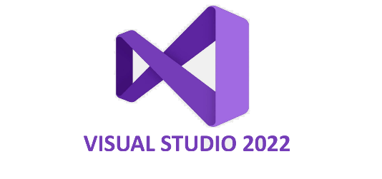

# Testing

Table 1: Unit Tests

|  |  |  |  |  |  |
| --- | --- | --- | --- | --- | --- |
| **Test Number** | | **Test Name** | **Description** | | **Status** |
| 1 | pickingUpTest | | | The user can pick up all five products in the VR environment, with smooth and responsive handling. Visual cues and clear instructions guide the process. | Pass |
| 2 | teleportTest | | | The user teleports to the next navigation starting point after picking up each product. | Pass |
| 3 | FPS_Test | | | The frame rate is higher than 60 frames per second. | Pass |
| 4 | colorsTest | | | The colors of the supermarket are correct, and there are no pink objects. | Pass |
| 5 | losingCanvasTest | | | If the user fails to pick up the correct product within three times the movie length, a losing canvas will pop up. | Pass |
| 6 | losingTeleportTest | | | After clicking ‘OK’ on the “Not Found” canvas, the player should be teleported to the correct starting navigation point. | Pass |
| 7 | finishingTest | | | A finishing canvas pops up when the player picks up the last product, preventing further movement. | Pass |
| 8 | CSV_Test | | | The CSV file displays the correct results, including starting time, finding times, and whether each item was found. | Pass |

# 

# User Manual

**General** Welcome to the Virtual Supermarket Test (VST). VST is a diagnostic game designed to detect Alzheimer’s disease in its early stages by assessing the subject’s daily functionality and basic navigation skills. The game takes place in a supermarket environment with sound, where the subject is required to watch short movies and pick up products.

The setup involves a subject and an assessor. The assessor should cast the Oculus device to their phone or another console using the Meta Horizon application and monitor the subject throughout the project. After successfully casting, the assessor should open the application inside the Oculus device.

In addition, the assessor must ensure the headset is fully charged before the diagnostic, the joystick has enough batteries, and there is a swivel chair available.

**System Acknowledgment**

1. The user should be instructed to sit on a swivel chair such as a computer chair.
2. The assessor gives the user the joysticks.
3. First, secure the ropes around the user’s hands, then have them hold the joysticks.
4. Ask the subject to move back and forth, and right and left.
5. Only after these steps, place the headset on the subject’s head and help them adjust it to the right size.

Once these steps are completed, you’re ready to begin.

**Instructions**

From this point, the subject will receive the game instructions and should follow them. The assessor should primarily observe and assist if needed. It’s recommended that the assessor tries the diagnostic game themselves before guiding the subject. The user should only use the joystick and point the red rays with it.

**Notice**: After watching the movie, the timer starts, and the subject has a time limit. The assessor must ensure the user understands the instructions and controls the system up to this point.

# Operation And Maintenance Guide

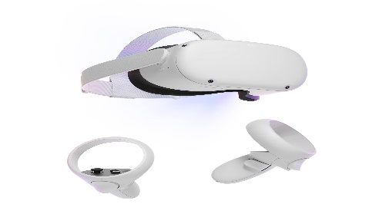Welcome to the Operation and Maintenance Guide for our VR-based diagnostic tool. This guide is designed to help you navigate the various settings and updates required to ensure optimal performance on Oculus devices, particularly the Oculus Quest 2. By following these instructions, you will be able to maintain the functionality and efficiency of your application, addressing any potential issues that may arise due to hardware differences or software updates.

Oculus Quest 2 Device

These project settings are suitable for the Oculus Quest 2. There are different player settings between Oculus devices. For example, the API level for the Oculus Quest 1 is only 26, while for the Oculus Quest 2, it is 29. Additionally, there are graphics and performance issues, so the application will not work. Furthermore, some object properties could change, such as player height, object colours, and so on.

Scene Changing: Note that the code and objects that appear in the scene are connected. Changing one of them code or objects requires you to change both.

Package Updating: Unity frequently publishes updates and even pre-creates some of them. Every download requires you to change the player settings accordingly and ensure there are no conflicts. It’s better to save the working version and keep the possibility to revert to the previous version.

By adhering to the guidelines outlined in this document, you can ensure that your VR-based diagnostic tool remains up-to-date and functional. Regular maintenance and careful management of updates will help you avoid conflicts and performance issues, allowing you to provide a seamless experience for users. Thank you for your attention to these details, and we wish you success in your ongoing development efforts.

# Results

The diagnostic game was evaluated with four participants—Ester Barak, Avi Ben Ari, Itzik Ben Ezra, and Tsurit Barak—each bringing unique experiences and challenges to the test. All participants are 75 years old, healthy with no signs of Alzheimer’s Disease, and have no prior experience with VR devices. They were tasked with locating five products within a virtual environment. Their performance varied, revealing both the potential and the limitations of the diagnostic game in its current form.

**Ester Barak:**

* Found the first product but was unable to locate the last four.
* Time to find the first product: 120 seconds.
* Observations: Experienced difficulty walking using the joysticks.

**Avi Ben Ari:**

* Found the first two products but did not find the remaining three.
* Time to find the first product: 93 seconds.
* Time to find the second product: 130 seconds.

**Itzik Ben Ezra:**

* Found the five products.
* Time to find the first product: 60 seconds.
* Time to find the second product: 76 seconds.
* Time to find the third product: 120 seconds.
* Time to find the second product: 116 seconds.
* Time to find the second product: 100 seconds.

**Tsurit Barak:**

* Found the five products.
* Time to find the first product: 80 seconds.
* Time to find the second product: 120 seconds.
* Time to find the third product: 90 seconds.
* Time to find the second product: 130 seconds.
* Time to find the second product: 140 seconds.

|  |  |  |  |  |  |  |
| --- | --- | --- | --- | --- | --- | --- |
|  | Number Products successfully found | Time taken to find Product 1 (seconds) | Time taken to find Product 2 (seconds) | Time taken to find Product 3 (seconds) | Time taken to find Product 4 (seconds) | Time taken to find Product 5 (seconds) |
| **Ester Barak** | 1 | 120 | - | - | - | - |
| **Avi Ben Ari** | 2 | 93 | 130 | - | - | - |
| **Itzik Ben Ezra** | 5 | 60 | 76 | 120 | 116 | 100 |
| **Tsurit Barak** | 5 | 80 | 120 | 90 | 130 | 140 |

Table 2: Tests Results

The test results highlight the diverse abilities of older adults in navigating VR environments and underscore the need for further refinement of the game. While Itzik Ben Ezra and Tsurit Barak successfully located all five products, the difficulties faced by Ester Barak and Avi Ben Ari suggest areas for improvement, particularly in simplifying navigation and extending search times. Addressing these issues will be crucial in making the game more accessible and effective for the older demographic, ensuring a better overall experience and enhanced diagnostic capabilities.

# Conclusions

Adapting the diagnostic game for older adults presents challenges, but it is feasible with the right adjustments and adaptations. The fact that the participants were able to find some products indicates that the game has potential. However, there are areas for improvement to enhance the user experience for older adults:

1. **Simplify Navigation**: The game should be redesigned to make navigation more intuitive and user-friendly. This adjustment will help older adults find all the products more easily.
2. **Extend Finding Time**: Increase the available time for finding products. The participants were close to locating all the items, suggesting that more time would improve their chances of success.
3. **Reduce Product Count**: Consider requiring users to find only three products instead of a larger number. This reduction can make the game more manageable and less frustrating.
4. **Adapt the Teaching Stage**: The initial learning phase of the game takes significantly longer for older adults compared to users aged 60 and younger. Simplifying and streamlining the teaching stage can help older users become more comfortable with the game mechanics more quickly.

By making these adjustments, the game can be better suited to the needs of older adults, improving both usability and overall effectiveness.

# Future Features

Given the current constraints on time and resources, there are several additional features that could significantly enhance the overall user experience. These improvements would not only make the application more immersive but also more effective in achieving its diagnostic goals. By prioritizing these enhancements, we can ensure a more robust and user-friendly tool for early Alzheimer’s disease detection.

Creating AI bot players: Integrating AI-driven characters into the supermarket environment enhances realism and allows for the measurement of user interactions, such as accidental bumps and confusion during encounters.

Sending the CSV file via email to a dedicated address can significantly enhance the convenience for the assessment team. This process can be streamlined using the Samba server protocol, ensuring secure and efficient file transfers. Additionally, automating this task can save time and reduce the risk of errors. Implementing this solution will also facilitate better organization and quicker access to necessary data, ultimately improving the overall workflow.

Displaying Videos: There is an issue with Unity APK file creation where short videos are not visible inside the Oculus Quest 2 without being connected to a computer. I believe this will be resolved in future updates, as the Unity and Oculus development teams continue to improve their platforms.

Personalization Task: This feature would incorporate images of close relatives or familiar faces into the navigation task, the task will require the participant to recognize his close relative while navigating to the correct product. Such a personalized element would provide deeper insights into the patient's cognitive abilities. the task would offer a more comprehensive evaluation of cognitive function, making the diagnostic process more tailored to individual patients and potentially yielding more accurate results.

By addressing these key areas we are committed to delivering a robust and effective diagnostic tool. These improvements will not only benefit the assessment team but also ensure a seamless and engaging experience for users, ultimately contributing to more accurate and early detection of Alzheimer’s disease.

# References

1. Liu, C. C., Kanekiyo, T., Xu, H., & Bu, G. (2013). Apolipoprotein E and Alzheimer disease: risk, mechanisms and therapy. *Nature Reviews Neurology*, *9*(2), 106-118.‏
2. Parizkova, M., Lerch, O., Moffat, S. D., Andel, R., Mazancova, A. F., Nedelska, Z., ... & Laczó, J. (2018). The effect of Alzheimer's disease on spatial navigation strategies. Neurobiology of Aging, 64, 107-115.‏
3. García-Betances, R. I., Arredondo Waldmeyer, M. T., Fico, G., & Cabrera-Umpiérrez, M. F. (2015). A succinct overview of virtual reality technology use in Alzheimer’s disease. *Frontiers in aging neuroscience*, *7*, 136325
4. <https://docs.unity3d.com/Manual/XRPluginArchitecture.html>
5. Boeykens, S. (2013). *Unity for architectural visualization*. Packt Publishing Ltd.
6. <https://www.meta.com/help/quest/articles/headsets-and-accessories/oculus-link/requirements-quest-link/>
7. Linowes, J. (2020). *Unity 2020 virtual reality projects: Learn VR development by building immersive applications and games with Unity 2019.4 and later versions*. Packt Publishing Ltd.
8. Lehtola, A. (2018). Optimizing Unity Projects.